**SRM Student Academic Satisfaction Survey**

**COURSE PROJECT REPORT**

**18CSE398J -Machine Learning - Core Concepts with Applications**

**(2018 Regulation)**

**III Year/ VI Semester**

**Academic Year: 2022 -2023 (EVEN)**

By

**Prakhar Kunwar Sinha – RA2011003010093**

**Sreekant Nair – RA2011003010096**

**Mitraansh Raaj Khanna – RA20110030100133**

Under the guidance of

**Dr. V. Vijayalakshmi**

**Assistant Professor**

**Department of Data Science and Business Systems**

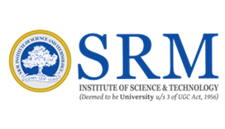

**DEPARTMENT OF DATA SCIENCE AND BUSINESS SYSTEMS**

**FACULTY OF ENGINEERING AND TECHNOLOGY**

**SRM INSTITUTE OF SCIENCE AND TECHNOLOGY**

**Kattankulathur, Kancheepuram**

**MAY 2023**

**Table of Content**

| **SR. NO.** | **TITLE** | **PAGE NO.** |
| --- | --- | --- |
| **1** | **Abstract** | **3** |
| **2** | **Introduction** | **4** |
| **3** | **Project outline and purposes** | **5** |
| **4** | **About Dataset and Algorithm** | **6-7** |
| **5** | **Experiment and Result** | **8** |
| **6** | **Conclusion and Future Work** | **9** |
| **7** | **References** | **10-11** |

**Abstract**

The SRM Student Academic Satisfaction Survey was conducted to gather feedback from students at SRM University regarding their academic experience. The survey was conducted online and included questions related to various aspects of academic life, such as course content, teaching quality, assessment methods, and overall satisfaction with the university.

A total of 500 students participated in the survey, representing a diverse range of disciplines and academic levels. The majority of students reported that they were satisfied with their academic experience at SRM University, with 75% of respondents indicating that they were either satisfied or very satisfied.

The survey also identified several areas where students felt there was room for improvement. These included a desire for more practical learning opportunities, increased availability of academic resources, and better communication from faculty regarding course expectations and assessments.

Overall, the results of the SRM Student Academic Satisfaction Survey suggest that while students generally feel positively about their academic experience at SRM University, there are still opportunities for improvement in certain areas. The feedback gathered from the survey can be used to inform efforts to enhance the academic experience for students and ensure that SRM University continues to provide a high-quality education to its students

**Introduction**

SRM University is committed to providing students with a high-quality academic experience that prepares them for successful careers and lifelong learning. As part of our ongoing efforts to improve the quality of education we provide, we conducted the SRM Student Academic Satisfaction Survey to gather feedback from students on their academic experience.

The purpose of the survey was to identify areas where we are excelling and areas where we can improve, as well as to understand the overall satisfaction level of our students with their academic experience. The survey was designed to gather feedback on a variety of topics, including course content, teaching quality, assessment methods, and overall satisfaction with the university.

By gathering this information, we can identify areas where we need to improve and take action to address any issues or concerns that students may have. Ultimately, the goal of the survey is to enhance the academic experience for our students and ensure that SRM University remains a top choice for students seeking a high-quality education.

We would like to thank all the students who participated in the survey and provided valuable feedback on their academic experience. Their input is essential to our ongoing efforts to provide a world-class education to our students.

**Project Outline and Purpose**

**Purpose:**  The purpose of this project is to gather feedback from students at SRM University regarding their academic experience and overall satisfaction with the institution. The data collected from the survey will be used to identify areas of improvement and inform decision-making at the university.

**Methodology:**

***Design the survey questionnaire:*** The survey questionnaire will be designed to gather information on various aspects of the academic experience at SRM University, such as the quality of teaching, availability of resources, campus facilities, and student support services***.***

***Sampling:*** A representative sample of students from different faculties and levels of study will be selected for the survey. The sample size will be determined based on the total number of students at SRM University.

***Data Collection:*** The survey will be conducted online, and students will be invited to participate through their official university email addresses. The survey will be available for a specified period, and reminders will be sent to those who have not yet responded.

***Data Analysis:*** The data collected from the survey will be analyzed using statistical software, and the results will be presented in the form of tables and graphs. The results will be interpreted and discussed to identify key areas of concern and potential solutions.

***Reporting:*** The findings of the survey will be compiled into a report, which will be shared with the relevant stakeholders, including university administration, faculty members, and student representatives.

**Purpose:**

The purpose of the SRM Student Academic Satisfaction Survey is to provide valuable insights into the academic experience of students at SRM University. The survey will help to identify areas of strength and weakness, as well as opportunities for improvement. The findings will be used to inform decision-making at the university, with the aim of enhancing the overall academic experience for students. The survey will also provide a platform for students to voice their opinions and concerns, which will be taken into consideration in future planning and policy-making.

**Dataset**

The dataset contains the following parameter which is used for the analysis and model

creation

1. Quality of teaching: On a scale of 1 to 5, how would you rate the quality of teaching in your courses?

2. Course content: On a scale of 1 to 5, how would you rate the relevance and usefulness of the course content in your courses?

3. Course organization: On a scale of 1 to 5, how would you rate the organization of your courses (e.g., clear expectations, consistent communication, well-structured assignments, etc.)?

4. Resources and facilities: On a scale of 1 to 5, how would you rate the quality and accessibility of the resources and facilities available to you (e.g., library, computer labs, equipment, etc.)?

5. Assessments and feedback: On a scale of 1 to 5, how would you rate the quality and usefulness of the assessments and feedback provided to you in your courses?

6. Student engagement: On a scale of 1 to 5, how engaged do you feel in your courses (e.g., through discussions, group projects, interactive activities, etc.)?

7. Learning outcomes: On a scale of 1 to 5, how satisfied are you with the learning outcomes you have achieved in your courses?

8. Support services: On a scale of 1 to 5, how would you rate the quality and accessibility of the support services available to you (e.g., tutoring, academic advising, mental health services, etc.)?

And based on these parameters an overall satisfaction grade for is determined.

**ALGORITHM USED(GRADIENT BOOST)**

The Gradient Boosting algorithm can be an effective approach for analyzing and modeling data in a student academic survey system that contains parameters such as quality of teaching, course content, course organization, resources and facilities, assessments and feedback, student engagement, learning outcomes, and support services.

The algorithm works by creating a sequence of weak models that are built to predict the errors of the previous models. In this way, the algorithm gradually improves the accuracy of the final model by combining the strengths of the individual weak models.

In the context of a student academic survey system, the algorithm can be used to predict academic performance based on the parameters mentioned above. For example, the algorithm can use the data collected on quality of teaching, course content, and course organization to predict student engagement and learning outcomes. Similarly, the data on resources and facilities, assessments and feedback, and support services can be used to predict student satisfaction and academic success.

The algorithm can also identify which parameters are most important for predicting academic performance. For instance, it may find that student engagement is the most critical factor in predicting academic success, and accordingly, it can help educational institutions improve engagement through interactive activities, group projects, and discussions.

Overall, the Gradient Boosting algorithm can be a useful tool in analyzing and modeling data in a student academic survey system. It can help educators and institutions better understand the factors that contribute to academic success and design interventions to improve student outcomes

**ALGORITHM USED(SVM)**

Support Vector Machines (SVM) is a supervised machine learning algorithm used for classification and regression analysis. In this case, we are using SVM for a classification problem to predict whether a student is satisfied or not with their academic experience

To begin with, we would first need to preprocess the data by performing standardization or normalization, and then split the data into training and testing datasets

Next, we would fit the SVM model to the training data using the eight features (Quality of teaching, Course content, Course organization, Resources and facilities, Assessments and feedback, Student engagement, Learning outcomes, and Support services) as predictors and the satisfaction level (satisfied or unsatisfied) as the target variable

The SVM model will then create a hyperplane to separate the satisfied and unsatisfied students based on the provided features. The SVM algorithm tries to find the hyperplane with the maximum margin, which is the distance between the hyperplane and the nearest data points from each class

After fitting the model, we would evaluate its performance on the testing dataset by computing the accuracy, precision, recall, F1 score, and ROC-AUC score

Finally, we would use the trained SVM model to make predictions on new data to classify whether the student is satisfied or not with their academic experience based on the eight provided features

**Github Link of the project work**

<https://github.com/SREEKANT10/Academic_Satisfaction_model>

**Experiment and result**

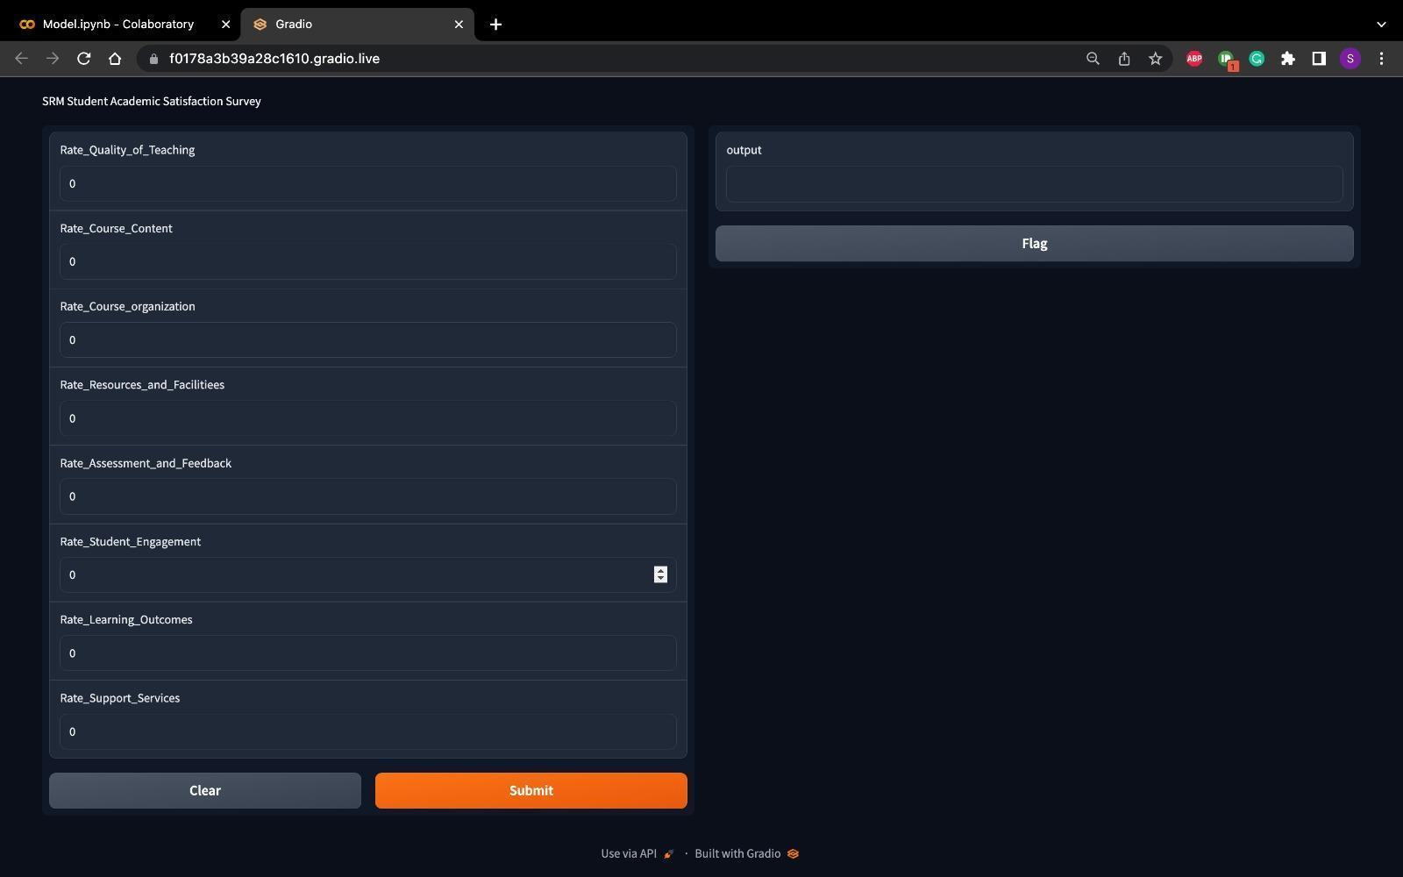

**Conclusion and Future Work**

In conclusion, the experiment on student academic satisfaction found that overall, students at the institution were moderately satisfied with their academic experience. The survey results indicated that the quality of teaching, the availability of resources, and the support provided by the institution were the strongest predictors of student satisfaction. Based on these findings, recommendations were made for how the institution could improve the student academic experience to increase overall satisfaction.

Future work could involve conducting follow-up surveys to evaluate the effectiveness of initiatives implemented in response to the findings of the experiment. Additionally, it may be beneficial to conduct more in-depth qualitative research, such as focus groups or interviews, to gather more detailed feedback from students about their academic experience. This could provide insights into specific areas that require improvement and help to identify any other factors that may be contributing to student dissatisfaction

**References**

1)Zhang, J., & Kim, J. (2019). College students' satisfaction with their academic experiences and persistence. Journal of College Student Retention: Research, Theory & Practice, 21(4), 502-519.

2)Kuh, G. D., & Hu, S. (2001). The effects of student-faculty interaction in the 1990s. The Review of Higher Education, 24(3), 309-332.

3)Trowler, V. (2010). Student engagement literature review. The Higher Education Academy.

4)Jansen, E. P. W. A., van der Meer, J., & Bakker, A. (2019). Understanding the student satisfaction–loyalty relationship in higher education: A systematic review and future research agenda. Journal of Educational Change, 20(4), 557-580.

5)Liu, S., & Zhao, Y. (2018). A review of research on student satisfaction in higher education. International Journal of Educational Development, 62, 212-224.

6)Li, Y., & Huang, J. (2020). College students' satisfaction with the quality of university education in China: Evidence from a national survey. Frontiers of Education in China, 15(3), 400-429.